Vitamin D – Percentage Reduction of Disease Incidence at Different Blood Serum Levels
This chart presents results of clinical research collated by www.grassrootshealth.org

More information and web-links at www.stargateuk.info/vitamind

 |  | Disease Incidence Prevention by Serum 25(OH)D Level
 | USA // Serum 25(OH)D, ng/ml |  |  | 6 | 8 | 10 | 12 | 14 | 16 | 18 | 20 | 22 | 24 | 26 | 28 | 30 |  | 32 |  | 34 | 36 | 38 | 40 | 42 | 44 | 46 |  | 48 | 50 |  | 52 | 54 |  | 56 |  | 58 | 60 |  | 62 | 64 | 66 | 68
 | UK // Serum 25(OH)D, nmol/L |  |  | 15 | 20 | 25 | 30 | 35 | 40 | 45 | 50 | 55 | 60 | 65 | 70 | 75 |  | 80 |  | 85 | 90 | 95 | 100 | 105 | 110 |  |  | 120 |  |  | 130 |  |  | 140 |  |  | 150 |  |  | 160 |  | 170
 | Studies of Individuals
 | Cancers, all combined |  |  |  |  |  |  |  |  |  |  |  |  |  |  |  |  |  |  |  |  |  | 77% | with | calc | ium
 | Breast Cancer |  |  |  |  |  |  |  |  |  |  |  |  |  |  |  |  | 30% |  |  | X | X | X | X | X | X |  | X | X |  | 83%
 | Ovarian Cancer |  |  |  |  |  |  |  |  |  |  |  |  |  |  |  |  |  |  |  |  | 12% |  |  |  |  |  | 17%
 | Colon Cancer |  |  |  |  |  |  |  |  |  |  |  |  |  |  |  |  | 31% |  |  |  | 38% |  |  | 60%
 |  |  |  |  |  |  |  |  |  |  |  |  |  |  |  |  |  |  |  |  |  | X | X | X
 | Non-Hodgkins Lymphoma |  |  |  |  |  |  |  |  |  |  |  |  |  |  |  |  | 12% |  |  |  |  | 18%
 | Type 1 Diabetes |  |  |  |  |  |  |  |  |  |  |  |  |  |  |  |  |  | 25% |  |  |  |  |  |  |  |  |  |  |  |  | 66%
 | Fractures, all combined |  |  |  |  |  |  |  |  |  |  |  |  |  |  |  |  |  |  |  |  | 25% |  |  |  | 50%
 | Falls, women |  |  |  |  |  |  |  |  |  |  |  |  |  | 72%
 | Multiple Sclerosis |  |  |  |  |  |  |  |  |  |  |  |  |  |  |  |  |  |  |  |  |  |  | 33% |  |  |  |  |  |  | 46% |  |  | 54%
 |  |  |  |  |  |  |  |  |  |  |  |  |  |  |  |  |  |  |  |  |  |  |  |  |  |  |  |  |  |  | X | X
 | Heart Attack (Men) |  |  |  |  |  |  |  |  |  |  |  |  |  |  |  |  |  |  |  | 30%
 | Natural Experiments
 | Kidney Cancer |  |  |  |  |  |  |  |  |  |  |  |  |  |  |  |  |  |  | 23% |  |  |  |  |  |  |  |  | 49%
 | Endometrial Cancer |  |  |  |  |  |  |  |  |  |  |  |  |  |  |  |  |  |  |  |  |  |  |  |  |  |  | 37%
 | Rickets |  |  | 50% |  |  |  |  |  |  | 99%
Legend: |  |  |  |  |  |  |  |  |  |  |  |  |  |  |  |  |  |  |  |  |  |  |  |  |  |  | Chart prepared by: Garland CF, Baggerly CA
All percentages reference a common baseline of 25 ng/ml as shown on the chart.
%’s reflect the disease prevention |  | % | at the |  | beginning and ending of available data. |  |  |  |  |  |  |  |  | Example: |  |  | Breast |  |  | cancer incidence is reduced |  |  |  |  |  |  | by 30% |  |  | when the |  |  | serum level is
34 ng/ml vs the baseline of 25 ng/ml. There is an 83% reduction in incidence when the serum level is 50 ng/ml vs the baseline of 25 ng/ml.
The x’s in the bars indicate ‘reasonable extrapolations’ from the data but are beyond existing data.
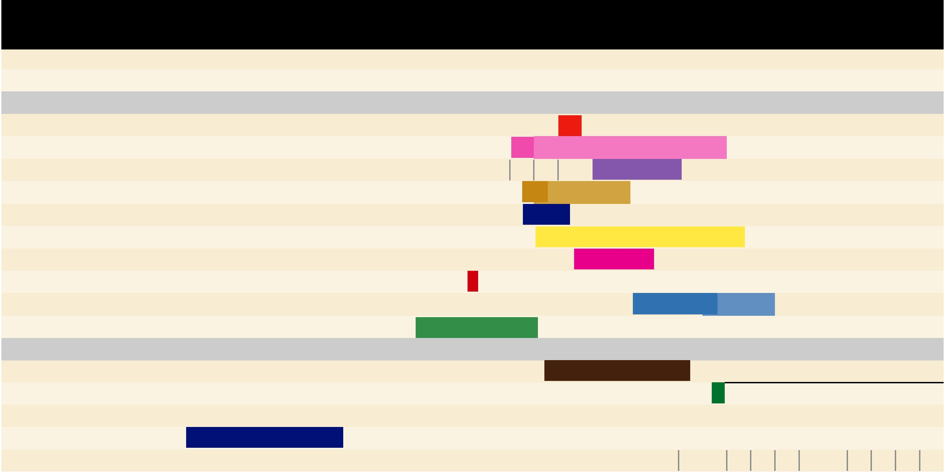
References:

All Cancers: Lappe JM, et al. Am J Clin Nutr. 2007;85:1586-91. Breast: Garland CF, Gorham ED, Mohr SB, Grant WB, Garland FC. Breast cancer risk according

to serum 25-Hydroxyvitamin D: Meta-analysis of Dose-Response (abstract).American Association for Cancer Research Annual Meeting, 2008. Reference serum 25(OH)D was 5 ng/ml.

Garland, CF, et al. Amer Assoc Cancer Research Annual Mtg, April 2008,. Colon: Gorham ED, et al. Am J Prev Med. 2007;32:210-6. Diabetes: Hyppönen E, et al. Lancet 2001;358:1500-3. Endometrium: Mohr SB, et al. Prev Med. 2007;45:323-4. Falls: Broe KE, et al. J Am Geriatr Soc. 2007;55:234-9. Fractures: Bischoff-Ferrari HA, et al. JAMA. 2005;293:2257-64. Heart

Attack: Giovannucci et al. Arch Intern Med/Vol 168 (No 11) June 9, 2008. Multiple Sclerosis: Munger KL, et al. JAMA. 2006;296:2832-8. Non-Hodgkin’s Lymphoma: Purdue MP, et al. Cancer Causes Control. 2007;18:989-99. Ovary: Tworoger SS, et al. Cancer Epidemiol Biomarkers Prev. 2007;16:783-8. Renal: Mohr SB, et al. Int J Cancer. 2006;119:2705-9. Rickets: Arnaud SB,

Copyright GrassrootsHealth, March 23rd 2010

